HANOI UNIVERSITY OF SCIENCE AND TECHNOLOGY
School of Information and communications technology

Software Design Document
Version 1.3

AIMS: An Internet Media Store
Subject: ITSS Software Development

Group Number: 23
List of participants:

Nguyen Trung Hieu 20225971 – Leader
Bui Huu Thanh Cong 20205176
Nguyen Hai Dang 20226019
Tran Nguyen Hai Dang 20226020
Nguyen Dang Truong Giang 20226036

Hanoi, 6/2025

Table of Contents

Table of Contents 1
1 Introduction 5
1.1 Objective 5
1.2 Scope 5
1.3 Glossary 5
1.4 References 5
2 Overall Description 7
2.1 General Overview 7
2.2 Assumptions/Constraints/Risks 7
2.2.1 Assumptions 7
2.2.2 Constraints 7
2.2.3 Risks 8
3 System Architecture and Architecture Design 9
3.1 Architectural Patterns 9
3.2 Interaction Diagrams 9
3.3 Analysis Class Diagrams 9
3.4 Unified Analysis Class Diagram 9
3.5 Security Software Architecture 9
4 Detailed Design 10
4.1 User Interface Design 10
4.1.1 Screen Configuration Standardization 10
4.1.2 Screen Transition Diagrams 10
4.1.3 Screen Specifications 10
4.2 Data Modeling 10
4.2.1 Conceptual Data Modeling 10
4.2.2 Database Design 10
4.3 Non-Database Management System Files 11
4.4 Class Design 11
4.4.1 General Class Diagram 11
4.4.2 Class Diagrams 11
4.4.3 Class Design 11
5 Design Considerations 13
5.1 Goals and Guidelines 13
5.2 Architectural Strategies 13
5.3 Coupling and Cohesion 14
5.4 Design Principles 14
5.5 Design Patterns 15

List of Figures
No table of figures entries found.

List of Tables
Table 1. Example of table design 10
Table 1. Example of attribute design 12
Table 1. Example of operation design 12
Table 4. Example of attribute design 14

Introduction

Objective
This document aims to describe the software design for the AIMS system — an Internet Media Store supporting order placement, rush delivery, and online payment via VNPay. It is primarily written for software developers, testers, and system architects involved in the implementation phase. This SDD ensures that all parties have a shared understanding of the system structure and behavior based on the SRS.

Scope
The software product is AIMS, a desktop e-commerce platform designed for selling physical media products such as books, CDs, and DVDs. It includes functionality such as product browsing, cart management, checkout, and VNPay payment processing.
The design excludes logistics tracking, support for digital media, and third-party marketplace integration. However, it is built with extensibility in mind, especially for integrating future payment methods through abstraction (e.g., PaymentGateway interface).

Glossary
No | Term | Explanation | Example | Note
1 | token | A piece of data created by server, and contains the user's information, as well as a special token code that user can pass to the server with every method that supports authentication, instead of passing a username and password directly. | JSON Web Token (JWT) | Compact, URL-safe and usable especially in web browser single sign-on (SSO) context.
2 | VAT | Value-Added Tax applied to the base price of physical goods. In AIMS, a 10% VAT is added to product prices at checkout.
3 | Physical Media Product | Tangible media products that can be shipped and physically handled.
4 | Cart | A temporary container holding customer-selected products before placing an order.
5 | Rush Order Delivery | A delivery option for customers who want to receive their products within 2 hours.
6 | VNPay | A payment gateway used to process credit card transactions.
7 | Product Manager | A user role responsible for managing product catalog including add, edit, delete operations.
8 | Administrator | A user role with permissions to manage user accounts, roles, and system-level configurations.
9 | Invoice | A document summarizing order details including items, prices, VAT, and delivery fees.
10 | Transaction | A payment event made through the VNPay gateway, includes ID, time, and amount.

References
- Centers for Medicare & Medicaid Services. (n.d.). System Design Document Template. Retrieved from Centers for Medicare & Medicaid Services: https://www.cms.gov/Research-Statistics-Data-and-Systems/CMS-Information-Technology/XLC/Downloads/SystemDesignDocument.docx
- API VNPay: https://sandbox.vnpayment.vn/apis/docs
- SDD Template Document
- AIMS problem statement
- Spring Boot Documentation: https://spring.io/projects/spring-boot
- MongoDB Manual: https://www.mongodb.com/docs/
- VNPay Sandbox Documentation: https://sandbox.vnpayment.vn/apis/

Overall Description

General Overview
The AIMS system is built using Spring Boot with RESTful API endpoints. MongoDB serves as the NoSQL database.
Key services include OrderService, CartService, ProductService, and VNPayService.
Payment logic follows the "Strategy Pattern" to abstract VNPay, enabling future gateways.
The VNPay Sandbox API is integrated for payment and refund.

Assumptions/Constraints/Risks

Assumptions
• Internet connection is available at runtime for VNPay API requests.
• MongoDB is hosted and accessible via the application configuration.
• The application is run as a desktop or self-hosted app using a web server.
• Orders can only be canceled before approval.

Constraints
• MongoDB NoSQL is used; relational queries and transactions are limited.
• VNPay is the only supported payment gateway at the moment.
• System timezone is UTC+7; date/time must be formatted consistently.
• Only Vietnamese is supported in the first version.
• Business rules are embedded in the service layer unless specified as configurable.
- Using Bootstrap

Risks
• Risk: VNPay API changes → Mitigation: use abstraction via PaymentGateway interface.
• Risk: No transactional rollback in MongoDB → Mitigation: design idempotent order processing.
• Risk: Failure during payment confirmation → Mitigation: retry logic and logging of pending transactions.

System Architecture and Architecture Design

Architectural Patterns
The system follows a Layered Architecture:
- Controller Layer using @RestController and @RequestMapping
- Service Layer for business logic (e.g., OrderService, CartService)
- Repository Layer with MongoDB-based repositories (e.g., OrderRepository)
Also uses Strategy Pattern for payment abstraction and Factory Pattern (optionally) for future delivery fee strategies.

Interaction Diagrams

Analysis Class Diagrams
https://github.com/hieuhb123/ISD.ICT.20242-23/blob/main/Architectural Design/Analysis Diagram

Unified Analysis Class Diagram
https://github.com/hieuhb123/ISD.ICT.20242-23/tree/main/Architectural Design/Communication Diagram

Security Software Architecture
• Authentication: Spring Security with JWT token
• Authorization: Role-based access (ADMIN, PRODUCT_MANAGER)
• Encryption: HTTPS with secure token handling for VNPay callback
• Logging/Auditing: OrderService logs events like place, cancel, refund via Logger

Detailed Design

User Interface Design
https://github.com/hieuhb123/ISD.ICT.20242-23/tree/main/InterfaceDesign

Screen Configuration Standardization

Screen Transition Diagrams

Screen Specifications
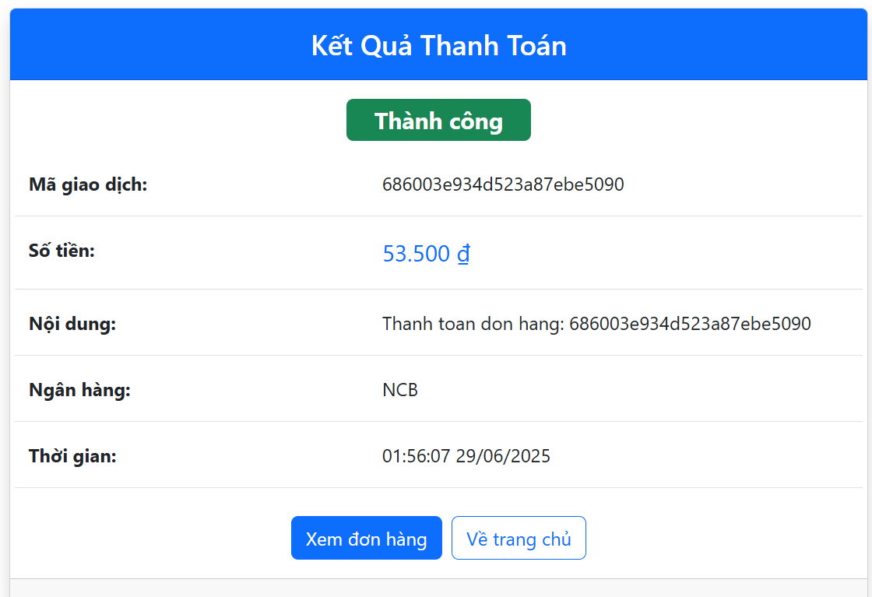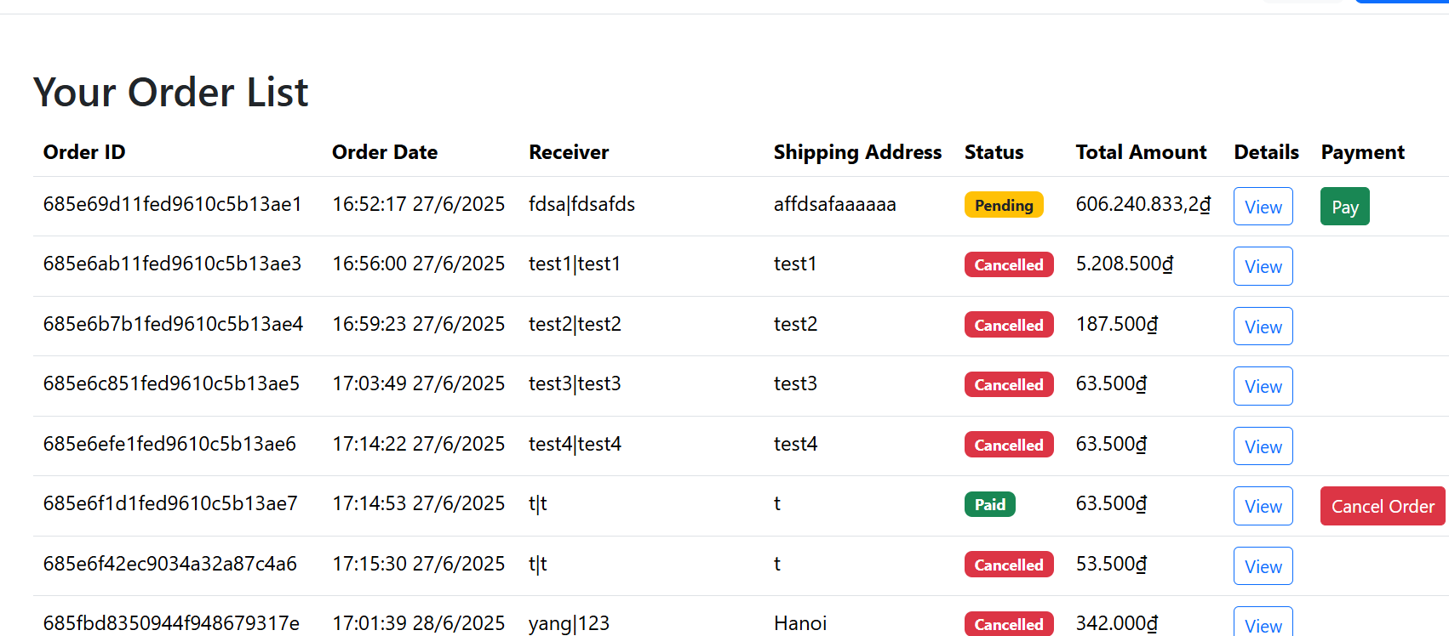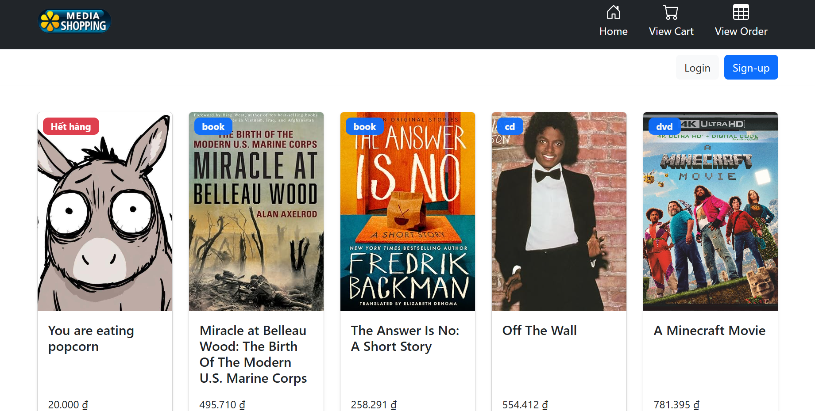

Data Modeling

Conceptual Data Modeling

Database Design
Entity Relationship Diagram Team Whiteboard - Whiteboard

Database Management System
MongoDB is used due to its flexibility in handling embedded documents (e.g., order items inside Order). Its NoSQL schema allows fast prototyping and scaling.

Database Diagram
MongoDB collections:
- orders
- products
- users
- transactions
- refunds

Database Detail Design
Table 1. Example of table design
# | PK | FK | Column name | Data type | Default value | Mandatory | Description
1 | x |  | ProductID | String
2 |  | x | CategoryID | String
 |  |  | status | String |  |  | ENUM: PENDING, CANCELLED, CONFIRMED
3 |  |  | totalAmount | Number |  |  | Total order price
4 |  |  | transactionId | String |  |  | Linked VNPay transaction

Non-Database Management System Files
application.properties or application.yml
Contains VNPay credentials, MongoDB URI, and security keys

Class Design

General Class Diagram

Class Diagrams
https://github.com/hieuhb123/ISD.ICT.20242-23/tree/main/Detailed Design

Class Design
Class Order:
# | Name | Data type | Description
1 | Id | String | Unique identifier
2 | Status | Enum | Order status
3 | totalAmount | Double | Total price
# | Name | Return type | Description
1 | cancel() | void | Change order status to cancelled if valid
2 | isCancelable() | Boolean | Return true of order is in pending state

Class “SampleClass1”
Table 2. Example of attribute design
# | Name | Data type | Default value | Description
1
2

Table 3. Example of operation design
# | Name | Return type | Description (purpose)
1
2

Parameter:
- x: Default value, description
- y: Default value, description
Exception:
- AException if …
- BException if …

Method
How to use parameters / attributes
Flowchart / activity diagram / sequence diagram if the method has a complex/special algorithm

State
State diagram if any

Class “SampleClass2”
…

Design Considerations

Goals and Guidelines
• Clean Architecture (Separation of concern)
• Easy maintainability
• Use Spring conventions (@Service, @Repository)

Architectural Strategies
• Abstraction for external systems (VNPay) via interface
• Domain-driven design for Order lifecycle
• Retry logic for network communication

Design and Program Evaluation
# | Class Name | PIC | Cohesion | SRP | Solution
1 | View Product Detail | Hieu | High | Yes
2 | Manage Cart | Hieu | High | No | Extract payment handling service
3 | VNPayService | Truong Giang | No | Yes | Split validation logic out
4 | RefundTransactionService | Truong Giang | High | Yes

Cohesion & SRP
Explain in detail for each class in the table.
Table 4. Cohesion & SRP of AIMS
# | Class Name | PIC | Cohesion | SRP | Solution
1 | Order | Truong Giang | High | no
2 | OrderService | Truong Giang | High | no
3 | InMemoryOrderRepository | Truong Giang | High | No
4 | OrderNotFoundException | Truong Giang | High | No

Coupling & Other SOLID
Explain in detail for each problem in the table. Each problem, you may provide a class diagram before and after the improvement.
Table 5. Coupling & other SOLID of AIMS
# | Problem | PIC | Location | Solution
1 | Tight coupling to VNPay | Truong Giang | OrderService | Use PaymentGateway interface (Strategy Pattern)
2 | No DI Container | Truong Giang | OrderService | Use constructor injection with Spring
3 | Tight coupling to VNPay | Truong Giang | OrderService VNPayService | Use PaymentGateway interface (Strategy pattern)
4 | Hardcoded refund logic | Truong Giang | RefundService | Abstract refund logic by strategy
5 | No block User | Hieu | Manage User | Added block/unblock functionality with visual status indicators
6 | Inconsistent Display | Hieu | View Product | Created unified product detail template with conditional rendering for type-specific fields
7 | Quantity Validation Bug | Hieu | Manage Cart | Fixed quantity validation logic to only check limits when increasing quantities
8 | Session Persistence | Tran Dang | Sign In/ Sign Up | Persistent Authentication
9 | Data Integrity Bug | Tran Dang | Update Product | Resolved the vast majority of bugs related to the product manager's CRUD (Create, Read, Update, Delete) operations

Design Patterns
Principle | Applied? | Explanation
SRP | Applied | Services split by domain logic
OCP | Applied | Payment logic can be extended
LSP | Applied | VNPayService behaves as PaymentGateway
ISP | Partial | PaymentGateway, RefundProcessor are interface-specific
DIP | Partial | Spring DI used for injecting services; can improve configuration

